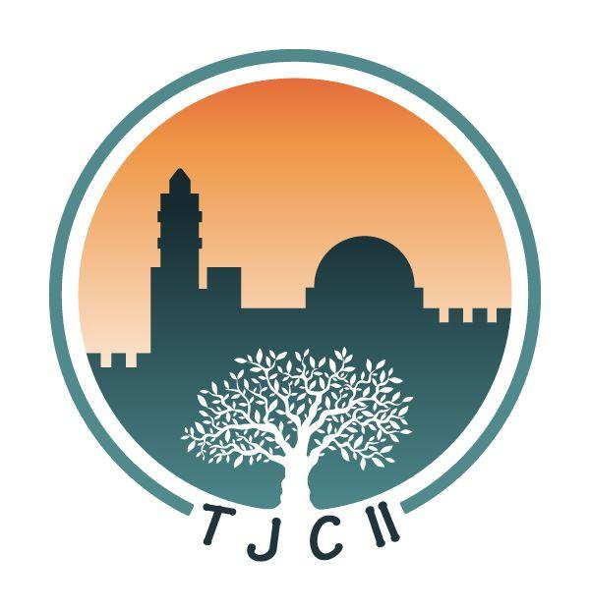
14. May 2021

Dear Brothers and Sisters in TJCII!

Shalom, greetings from Hainburg!

From 5 – 9 July 2021, the TJCII International Formation Center will be hosting an online course devoted to the topic of Intercession in TJCII. On the following page you will find the schedule of the course, along with the basic objectives of each topic.

This course will be very similar to the “Come and See” Course that took place last summer. The course will include 2 teaching sessions a day and small groups for those who wish. A small booklet study will also be prepared for ongoing study.

You are receiving this letter as a national leader or leader/member of a national intercession team. Please pass this information on to others in your group. Please note that this course will not be an introduction to the vision of TJCII, therefore, it would be good for the participants to have a basic knowledge of the vision. However, we want to leave the course open for any who are interested.

Our hope is that this course can help in the following ways:
- To encourage and strengthen the foundations of the ministry of intercession in TJCII.
- To network intercessors from around the world.
- To provide a resource for the national teams; to strengthen and perhaps build up national/regional TJCII intercession groups.

We would like to provide opportunities for sharing during the time of the course. We hope to provide a variety of opportunities, and for this we ask your help. Last year during the Come and See Course, our Formation Center team offered four different times during the day when we facilitated international sharing groups. Other groups met (online or onsite) with their national leaders. We envision something similar this year. Please let us know if you would be willing to facilitate a regional/national group this year.

Each teaching session will be recorded and uploaded to the virtual classroom for those who are not able to join the teaching live. The teachings will not be distributed outside of this course setting until after the course is finished.

To register for the course, please click this link: https://forms.gle/ayHqf8NwNEuwUPUb6

If you have any questions at all, please feel free to write our team at: formationcenter@tjcii.org

We have asked a couple of intercessors to keep this course, and all of us especially in prayer - please ask the intercessors in your area to pray for us as well!

The Intercession Course Team:

Eyal, Johanna, Vera, and Mary Paul

Intercession Course Curriculum
July 5 – 9 2021
Times listed are according to Central European Time

Monday, July 5
16 – 17:15 - Introduction/Scriptural Basis
Elizabeth Kamau (Kenya)
18 – 19:15 - TJCII Intercession in Context – History, Testimonies
Marlene Waldman (USA)

Tuesday, July 6
16 – 17:15 - Hearing from the Lord/Walking with the Lord
TBA
18 – 19:15 - What is Prophetic intercession?
Bracha Cale (Israel)

Wednesday, July 7
16 – 17:15 - Identificational Repentance
TBA
18 – 19:15 Testimonies/Examples
TBA

Thursday, July 8
16 – 17:15 – Safeguards in Spiritual Warfare
Dave and Raquel Pyles (USA)
18 – 19:15 – Being Ecumenically/Culturally Sensitive
Sr. Mary Paul Friemel (Austria/USA)
Maria Pibernus (Argentina)

Friday, July 9
14 – 15:00 - A time of intercession together

16 – 17:15 – Practical Intercession/Leadership questions within the TJCII structure
Vera Garcia (Portugal)
18 – 18:30 – Wrapping Up, Shabbat (shorter session)

Basic structure of the Intercession Course
- Small groups – meet once a day to practice
- Handbook study guide
- Two teachings a day

